Response Form to the Consultation Paper on the amendement of Article 19 of CSDR RTS on Settlement Discipline

Responding to this paper
ESMA invites comments on all matters in this consultation paper and in particular on the specific questions. Comments are most helpful if they:
- respond to the question stated;
- indicate the specific question to which the comment relates;
- contain a clear rationale; and
- describe any alternatives ESMA should consider.
ESMA will consider all comments received by 9 September 2022
Instructions
In order to facilitate analysis of responses to the Consultation Paper, respondents are requested to follow the below steps when preparing and submitting their response:
- Insert your responses to the questions in the Consultation Paper in the present response form.
- Use this form and send your responses in Word format (pdf documents will not be considered except for annexes);
- Please do not remove tags of the type <ESMA_QUESTION _SETD_1>. Your response to each question has to be framed by the two tags corresponding to the question.
- If you do not wish to respond to a given question, please do not delete it but simply leave the text “TYPE YOUR TEXT HERE” between the tags.
- When you have drafted your response, name your response form according to the following convention: ESMA_SETD_nameofrespondent_RESPONSEFORM. For example, for a respondent named ABCD, the response form would be entitled ESMA_SETD_ABCD_RESPONSEFORM.
- Upload the form containing your responses, in Word format, to ESMA’s website (www.esma.europa.eu under the heading “Your input – Open Consultations” -> Consultation Paper on the clearing and derivative trading obligations in view of the benchmark transition”).
Publication of responses
All contributions received will be published following the close of the consultation, unless you request otherwise. Please clearly and prominently indicate in your submission any part you do not wish to be publically disclosed. A standard confidentiality statement in an email message will not be treated as a request for non-disclosure. A confidential response may be requested from us in accordance with ESMA’s rules on access to documents. We may consult you if we receive such a request. Any decision we make not to disclose the response is reviewable by ESMA’s Board of Appeal and the European Ombudsman.
Data protection
Information on data protection can be found at www.esma.europa.eu under the heading Legal Notice.

Who should read this paper
All interested stakeholders are invited to respond to this consultation paper. In particular, this paper may be specifically of interest to CCPs, CSDs and their clients.

General information about respondent
Name of the company / organisation | EACH aisbl
Activity | Central Counterparty
Are you representing an association? | ☒
Country/Region | Europe

Questions
- Do market participants support removing the special process of collection and distribution of penalties by CCPs for cleared transactions? Please provide justifications, if possible supported by quantitative data.
<ESMA_QUESTION_SETD_1>
EACH welcomes the ESMA proposal to remove the special process provided by Article 19 of Settlement Discipline Regime (henceforth “Article 19 SDR” ).

We believe that the collection and distribution of all penalties should be through a single mechanism, as proposed by ESMA in its consultation. As stated in previous responses (linked here and here), EACH sees the double penalties systems currently provided by CSDR SDR as complex, costly, inefficient and unnecessarily duplicative for CCPs, CSDs, CCP members and CSD participants.

The single penalties mechanism provided by the suggested ESMA amendment would be more efficient and would resolve legal and operational risks posed by running two parallel systems, as well as eliminating unnecessary operating costs. Below we include diagrams of both the current duplicative system and the proposed single penalties system to visualise the latter system’s efficiency (Figures 1 and 2).

EACH would like to stress that we understand that this move to a single system is explicitly supported by CSDs and participants, in particular also in the context of improving the SDR overall since its launch in February 2022.

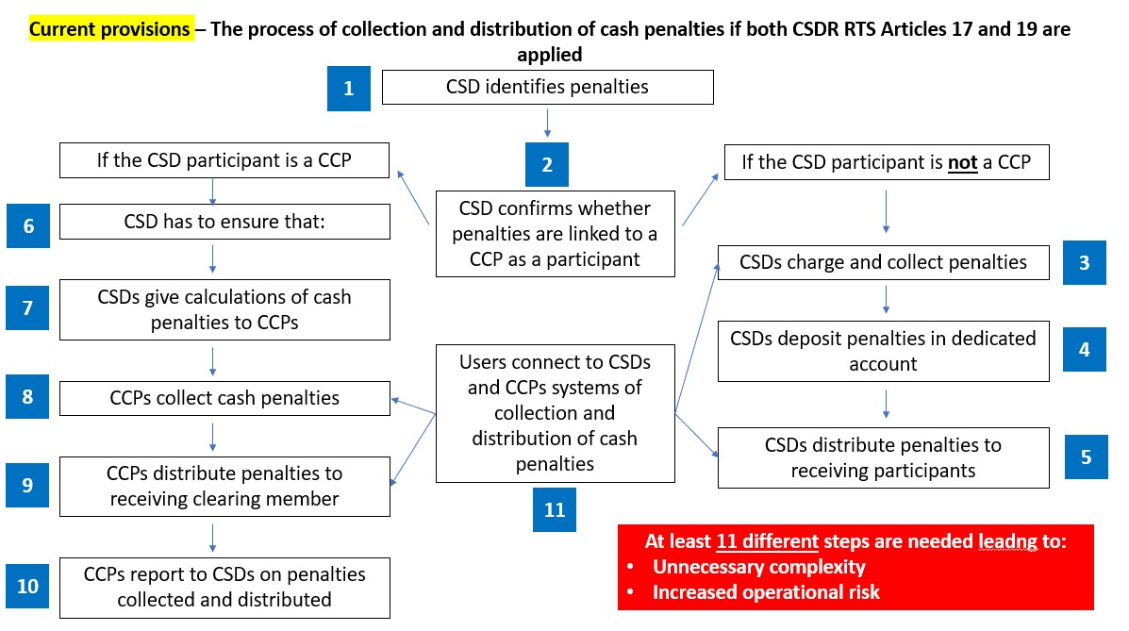
Figure 1 - Penalties process with the application of both CSDR SDR RTS Articles 17 and 19

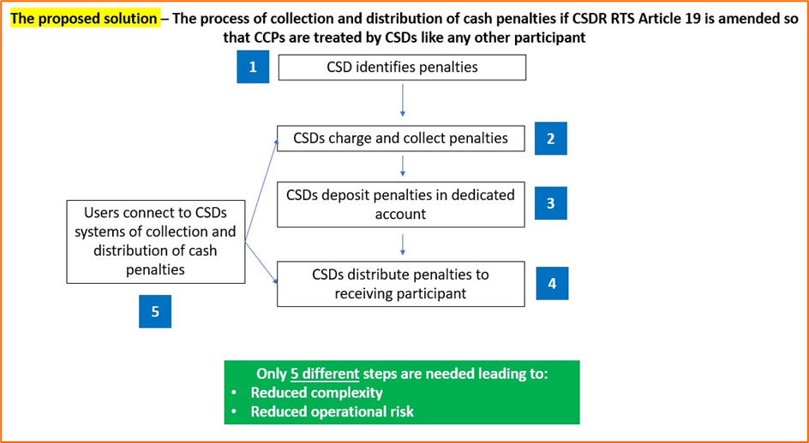
Figure 2 - Penalties process with CSDs treating collecting and redistributing all penalties
<ESMA_QUESTION_SETD_1>

- Do market participants support amending Article 19 of the CDR on Settlement Discipline as suggested in Annex IV? Please provide justifications, if possible supported by quantitative data.
<ESMA_QUESTION_SETD_2>
EACH supports the essence of ESMA proposed amendments to Article 19 SDR, as we believe they go in the direction of achieving a single mechanism for the collection and distribution of penalties.

We would however suggest some editorial changes (See Box 1 on the next page) to ensure that the text proposed is aligned with the Level 1 (first two edits) and provides legal certainty that CSDs are in charge of i, ii and iii (third edit).

Furthermore, EACH also supports the gist of the amendment to Article 19(b) as it gives the CCPs the legal remit to recover any losses from imbalances, and that CCPs can establish the mechanism to do so in their rulebook. It is important for EACH that CCPs may recover losses from penalties imbalances, because as the consultation paper notes, these losses stem from penalties, where failure to deliver was not the fault of the seller.

We would however suggest deleting the sentence ‘received from or paid to the other CSD participants pursuant to point (a)’ as we consider it unnecessary to clarify who the CCPs receive from and pay to. In addition, we respectfully believe that think the reference is incorrect as CCPs do not have contacts with CSD participants.

Box 1 – Changes suggested

Article 19 - Penalty mechanism for transactions cleared by a CCP where the participant is a CCP
“With respect to settlement fails related to transactions cleared by CCPs Where the failing or the receiving participant is a CCP,
- CSDs shall

- calculate and apply the cash penalties in accordance with Article 16;
- collect from and distribute to their participants the net amount of cash penalties in accordance with Article 17; and
- manage costs relating to the application of the cash penalties mechanism to such transactions in accordance with Article 18.

(b) CCPs may allocate to their clearing members the net amount of penalties, credit or debit, received from or paid to the other CSD participants pursuant to point (a). In such cases, CCPs shall establish relevant mechanism in their rules.”

<ESMA_QUESTION_SETD_2>

- Do market participants support delaying the application of the envisaged amendment by six months after the publication of the amending RTS in the Official Journal of the EU? If not, what would be appropriate implementation period in your view? Please provide explanations.
<ESMA_QUESTION_SETD_3>
EACH supports the 6-month delay of the envisaged amendment and that all market participants implement at the same time, as opposed to a staggered approach.’
<ESMA_QUESTION_SETD_3>

