Reply form

for the Call for Evidence on a Comprehensive Approach for the Simplification of Financial Transaction Reporting

Responding to this paper
ESMA invites comments on all matters in this call for evidence and in particular on the specific questions. Comments are most helpful if they:
- respond to the question stated;
- indicate the specific question to which the comment relates;
- contain a clear rationale; and
- describe any alternatives ESMA should consider.
ESMA will consider all comments received by 19th September 2025.
Instructions
In order to facilitate analysis of responses to the Call for Evidence, respondents are requested to follow the below steps when preparing and submitting their response:
- Insert your responses to the questions in the Call for Evidence in the present response form.
- Use this form and send your responses in Word format (pdf documents will not be considered except for annexes);
- Please do not remove tags of the type <ESMA_QUESTION _CASR_1>. Your response to each question has to be framed by the two tags corresponding to the question.
- If you do not wish to respond to a given question, please do not delete it but simply leave the text “TYPE YOUR TEXT HERE” between the tags.
- When you have drafted your response, name your response form according to the following convention: ESMA_CASR_nameofrespondent_RESPONSEFORM. For example, for a respondent named ABCD, the response form would be entitled ESMA_CASR_ABCD_RESPONSEFORM.
- Upload the form containing your responses, in Word format, to ESMA’s website (www.esma.europa.eu under the heading “Your input – Open Consultations” -> Call for evidence on a comprehensive approach for the simplification of financial transaction reporting”).
Publication of responses
All contributions received will be published following the close of the consultation, unless you request otherwise. Please clearly and prominently indicate in your submission any part you do not wish to be publicly disclosed. A standard confidentiality statement in an email message will not be treated as a request for non-disclosure. A confidential response may be requested from us in accordance with ESMA’s rules on access to documents. We may consult you if we receive such a request. Any decision we make not to disclose the response is reviewable by ESMA’s Board of Appeal and the European Ombudsman.
Data protection
Information on data protection can be found at www.esma.europa.eu under the heading Legal Notice.
Who should read this paper

This paper is primarily addressed to all financial market participants and in particular reporting entities and market infrastructures, as well as to trade associations and other stakeholders involved in financial regulation, investor education, and retail investment market developments. It seeks input on major cost drivers linked to derivative regulatory reporting and the identification of possibilities on integration, streamlining and simplification.

The paper is also relevant to competent authorities, with competences in the context of MiFIR, EMIR, SFTR regulation.

General information about respondent
Name of the company / organisation | Derivatives Service Bureau
Activity | Other Financial service providers
Are you representing an association? | ☐
Country/Region | Europe

Questions

- Do stakeholders agree with the description of the key challenges outlined above? Is there any other issue linked to multiple regulatory regimes with duplicative or inconsistent requirements that is not reflected in this section? Out of the 10 sources of costs identified in this section and the ones that you may add, what are the three main cost drivers in your view?
<ESMA_QUESTION_CASR_1>
TYPE YOUR TEXT HERE
<ESMA_QUESTION_CASR_1>

- Do stakeholders agree with the proposed principles and related description? Is there any other aspect/principle that should be considered?
<ESMA_QUESTION_CASR_2>
The Derivatives Service Bureau (DSB), the numbering agency and service provider for the International Securities Identification Numbers (OTC ISIN) (ISO 6166), the Unique Product Identifier (UPI) (ISO 4914), the Classification of Financial Instruments (CFI) (ISO 10962) and the Financial Instrument Short Names (FISN) (ISO 18774) for OTC derivatives, agrees with the proposed four principles.

The DSB launched the OTC ISIN Service in 2017 in readiness for the mandate under MiFID II/MiFIR to identify OTC derivatives in transaction reporting to support market abuse investigation and detection and sets out below how the OTC ISIN effectively supports the four proposed key principles.

Ensure global alignment
The DSB’s globally recognised identifiers are developed and maintained within the International Organization for Standardization (ISO) framework.

The OTC ISIN, UPI, CFI and FISN are globally recognised and adopted ISO standards for identifying, classifying and describing OTC derivatives. Each of these OTC derivative identifiers is available for use to trade, clear, settle, administer or report OTC derivatives transactions.

Together they form the OTC derivative identifier framework and are designed to be complementary whilst having different levels of granularity. The level of granularity depends on the purpose for which the identifier has been created.

- CFI: Enables consistent grouping of instruments with similar features by providing a common set of classification definitions.
- UPI: Product level identification to enable aggregation of OTC derivatives transaction reports to provide regulators with a consistent view of systemic risks.
- OTC ISIN: Instrument identification for market abuse detection.
- FISN: Provides short descriptions of essential information about financial instruments in a human-readable format, assigned concurrently with the CFI, UPI and ISIN.
The CFI dataset is a subset of the UPI dataset and the UPI dataset is a subset of the OTC ISIN dataset. This means that the data attributes and codes for the corresponding UPI and CFI can be accessed within each OTC ISIN record. This is illustrated below in Table 1 which shows the data attributes of the CFI, UPI and OTC ISIN for an index Credit Default Swap.

Table 1: Example data attributes of a CFI, UPI and OTC ISIN for an Index Credit Default Swap
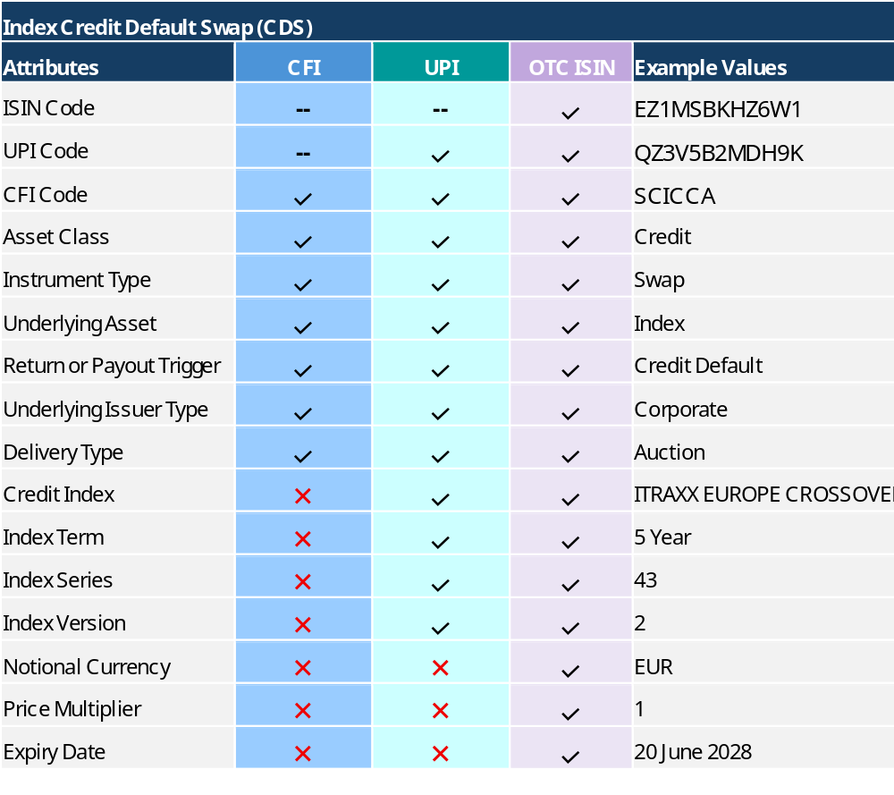

The OTC ISIN was designed from the outset to be consistent with CPMI-IOSCO UPI technical guidance meaning it is complementary to the UPI, with alignment of the core dataset. This holistic design is deliberate and in line with the CPMI-IOSCO UPI technical guidance which states that whilst the primary use case of the UPI is risk aggregation, “the UPI could be leveraged to create other more granular derivatives identifiers for other purposes”.

More broadly, the ISO standards issued by the DSB work in conjunction with the wider family of ISO standards for financial services. The OTC ISIN as the instrument identifier and the UPI as the product identifier utilise other ISO standards where possible to define the underlier. For example, the underlying legal entity of a single name CDS is identified based on the LEI (ISO 17442); the underlying currency pairs for FX Derivatives are identified based on the currency code (ISO 4217).

Decrease overlaps to reduce reporting burden
Where the data attributes are already within the OTC ISIN record the DSB suggests ESMA give consideration to not requiring separate reporting of such data. Data quality is higher when data attributes are within the OTC ISIN ‘wrapper’ as the data is cleansed and normalised leading to a harmonised approach. Equally, duplicative reporting can be avoided when the data attributes which are embedded within an identifier are not required to be reported separately, thereby assisting in decreasing the overlap of reporting.

Preserve information scope
Within the OTC derivative identifier framework, the OTC ISIN is the instrument identifier and the granularity of the OTC ISIN has been designed specifically to identify OTC derivatives in transaction reporting to support market abuse investigation and detection.
The granularity of information within the OTC ISIN ensures that the information scope is preserved by reporting the identifier alone. Utilising a less granular identifier such as the CFI or UPI, which have been designed for different, specific purposes, would require the separate reporting of additional data attributes to preserve the information scope.
When considering preservation of information scope, the choice of OTC identifier for baskets is also critically important. The OTC ISIN embeds within it information on underlying basket constituents whereas neither the CFI nor the UPI include this information.
As set out in the DSB analysis provided to question 5, in a sample of approximately 85,000 OTC ISINs created for derivative baskets in Q1 2025, the number of underlying constituents averaged at 38, and ranged from 2 to 2,347.
If the OTC ISIN were not used, this would lead to additional data fields, from 2 to 2,000+, being reported outside the identifier by firms for one OTC derivative, increasing significantly the potential for data errors. It could also increase the difficulty in regulators consuming and analysing this data because two firms can report information on the same underlying basket constituents differently e.g. list the constituents in different orders, formats etc. Through the use of the OTC ISIN, the constituent data is cleansed and normalised, ensuring harmonisation of the data provided by firms to ensure such issues do not arise.
As part of consideration regarding the principle of preserve information scope, ESMA may also wish to consider for instruments that are similar in risk and characteristics across both ETD and OTC derivatives, whether the identifiers used should have similar data to make comparison easier. As set out in the DSB’s response to Question 5, the analysis indicates the OTC ISIN would be the most effective identifier to support this comparison given the data attributes embedded in the OTC ISIN are consistent with the data attributes embedded in the ETD ISIN.

Balance cost and benefit
The existing infrastructure and workflows already built by industry and the regulators are based on the ISIN across all asset classes including for OTC derivatives. Therefore, the OTC ISIN has the benefit of not requiring any additional implementation costs.
Should ESMA decide to implement the revised OTC ISIN for interest rate swaps (IRS) in accordance with the European Commission Delegated Act on OTC derivative identifying reference data (“DA”) as proposed in ESMA’s MIFIR Review Consultation Package 4 on the derivatives transparency regime, the following benefits should also accrue.
The revised IRS OTC ISIN would remove the expiry date and include additional data elements. This would replace redundant daily ISIN creation with a single ISIN representing each IRS OTC derivative which the market considers distinct.
The DSB estimates that the move to this revised ISIN could result in approximately 96% to 99% reduction of ISINs being created for fixed-float interest rate swaps supporting a better cost and benefit outcome for the industry.

<ESMA_QUESTION_CASR_2>

- What are the key advantages of option 1a and how do these benefits address the issues in section 3?
<ESMA_QUESTION_CASR_3>
TYPE YOUR TEXT HERE
<ESMA_QUESTION_CASR_3>

- What are the key limitations and potential risks of option 1a? For example, do you consider the adaptation of the emir template to cover the data points used for market abuse surveillance as meeting the general objective of reducing the reporting burden, and why?
<ESMA_QUESTION_CASR_4>
TYPE YOUR TEXT HERE
<ESMA_QUESTION_CASR_4>

- What components are missing or not adequately addressed in option 1a? Why are these elements important, and how might their inclusion change the evaluation or implementation of option 1a?
<ESMA_QUESTION_CASR_5>
The DSB notes that firms are best placed to advise ESMA on their preferred option depending on their reporting obligations, model and systems. The DSB provides data analysis below which is relevant across all options to aid consideration of:
- Maintaining data quality in the context of a potential move to single sided reporting; and
- supporting effective instrument comparability across OTC derivatives and ETDs.
These points are expanded below with supporting data analysis.

- Maintaining data quality in the context of a potential move to single-sided reporting

Whilst revision of dual sided reporting is a feature of all four options, the DSB notes the concern regarding whether a move to single sided reporting will risk a decrease in data quality. To that end, the DSB has undertaken analysis with respect to the information encapsulated in the OTC ISIN and the UPI to assist ESMA’s decision-making.

In summary and based on this analysis, the DSB considers the continued use of the OTC ISIN for transaction reporting will best support ESMA’s objective to maintain data quality in a move to single sided reporting, for the following reasons:

- The granularity of the OTC ISIN has been designed specifically to identify OTC derivatives in transaction reporting to support market abuse investigation and detection, meaning only a single data point (the OTC ISIN) needs to be reported. A single data point of information means fewer errors. ESMA’s data analysis of June 2023 EMIR data (see page 5 of ESMA’s response to EC’s consultation on OTC derivative identifiers) showed the rate of consistent reporting was significantly higher with less data points – 88% compared to 63%.
- The OTC ISIN and UPI have different levels of granularity suited to their specific use cases, with the DSB comparative analysis showing that the OTC ISIN can encapsulate up to 7 additional data attributes than the UPI for some OTC derivatives.
- For OTC derivative baskets, the OTC ISIN embeds within it information on the underlying basket constituents whereas the UPI does not. In a sample basket product analysed by the DSB, the number of underlying constituents averaged at 38 and ranged from 2 to 2,347. This could significantly increase the potential for data errors if these constituents were reported separately, outside the identifier.
- Should ESMA decide to implement the revised OTC ISIN for interest rate swaps (IRS) in accordance with the European Commission Delegated Act on OTC derivative identifying reference data (“DA”), the reduction in the number of OTC ISINs created for IRS will be significant. DSB estimates that for fixed-floating IRS, the reduction in the number of OTC ISINs would be almost 96% for all term contracts and 99.7% for benchmark term contracts. This reduction of data points will further support ESMA’s goal for reducing burden by removing any redundant identifiers, whilst not eliminating key instrument information or compromising data quality.

Taken together, the above can significantly reduce interpretation issues, inconsistencies and errors in data. Further details are provided below to support the above.

  - Attributes embedded within the OTC ISIN and the UPI

As illustrated in Table 1 under question 2, the OTC ISIN has more embedded data attributes than the UPI for the same OTC derivative.

The DSB maintains 106 product templates across 6 asset classes. Table 1.1A below shows:
- the range for the number of additional attributes embedded within the OTC ISIN compared to the UPI; and
- those attributes which are embedded within an OTC ISIN but not within the parent UPI.

Table 1.1A: Range of attributes embedded in OTC ISIN compared to UPI

OTC Derivative asset class | Range of number of attributes within OTC ISIN greater than UPI | Attributes in the OTC ISIN which are not in the UPI
Credit | 3 to 7 | Expiry Date, Notional Currency, Price Multiplier
Commodities | 3 to 7 | Expiry Date, Final Price Type, Notional Currency, Price Multiplier, Reference Rate, Transaction Type, Underlier identifier
FX | 0 to 3 | Delivery Type, Expiry Date, Instrument ISIN Near Leg, Instrument ISIN Far leg, Place of Settlement, Price Multiplier, Settlement Currency
Rates | 1 to 4 | Expiry Date, Price Multiplier, Term of Contract Value, Term of Contract Unit
Equity | 2 to 6 | Expiry Date, Notional Currency, Price Multiple, Strike Price Type, Strike Price, Underlier identifier
Multi-assets | 6 | Expiry Date, Commodities Final Price Type, Commodities Transaction Type, Price Multiplier, Term of Contract Unit, Term of Contract Value

Table 1.1A illustrates:
- that the range for the number of attributes embedded within the OTC ISIN is greater than the range for the UPI for each asset class; and
- an OTC ISIN can encapsulate up to 7 additional data attributes than the UPI for some OTC derivatives.

  - Analysis on OTC derivatives underlying basket constituents

The choice of identifier for OTC derivatives with underlying baskets is critically important. The OTC ISIN embeds within it information on underlying basket constituents whereas the UPI does not because it was created to facilitate risk aggregation and is therefore a less granular identifier.

Table 1.2A shows the total number of OTC ISINs created for OTC derivatives with underlying baskets since the launch of the OTC ISIN Service in 2018 to 1 July 2025 by type of basket. The table also shows the maximum number of UPI permutations that could be created for each type of OTC derivatives basket.

Table 1.2A: Total number of OTC ISINs created for different OTC derivative baskets

Asset Class | Instrument Type | Product* | Number of Total OTC ISINs Created | Max Number of UPI permutations
Commodities | Forward | Multi_Exotic_Forward | 25,082 | 56
Commodities | Option | Multi_Exotic_Option | 18,018 | 3024
Commodities | Swap | Multi_Exotic_Swap | 37,615 | 84
Equity | Swap | Parameter_Return_Dividend_Basket | 205 | 3
Equity | Swap | Parameter_Return_Variance_Basket | 201 | 3
Equity | Swap | Parameter_Return_Volatility_Basket | 412 | 3
Equity | Swap | Portfolio_Swap | 812,005 | 21
Equity | Swap | Price_Return_Basic_Performance_Basket | 1,099,930 | 9
Equity | Swap | Price_Return_Basic_Performance_Basket_CFD | 15 | 3
Equity | Forward | Price_Return_Basic_Performance_Basket | 3,667 | 4
Equity | Forward | Price_Return_Basic_Performance_Basket_CFD | 17 | 2
Equity | Option | Basket | 1,104,938 | 216
Grand Total |  |  | 3,102,105 | 3,428
*See here for an explanation of the product descriptions

Table 1.2A shows that a total of 3.1 million OTC ISINs have been created for OTC derivatives with underlying baskets since 2018 to 1 July 2025. However, the maximum number of permutations of UPIs for these OTC derivatives is 3,428. The significantly lower number of UPIs to the actual number of OTC ISINs is due to the less granular level of data encapsulated within the UPI. In particular, the underlying basket constituent information is not included in the UPI’s attributes.

Table 1.2B below shows the range of the number of OTC ISINs created for Q1 2025 by number of basket constituents for “Price_Return_Basic_Performance_Basket” Equity Swap product type. Further analysis on other product types can be undertaken by the DSB, if required by ESMA.

Table 1.2B: Distribution of OTC ISINs created for OTC derivatives with underlying baskets in Q1 2025 by size of the basket for a “Price_Return_Basic_Performance_Basket” equity swap

Number of basket constituents | Number of OTC ISINs | Percentage of OTC ISINs (%)
2-5 | 49,667 | 58.38%
6-10 | 5,360 | 6.30%
11-20 | 6,243 | 7.34%
21-50 | 10,257 | 12.06%
51-100 | 6,558 | 7.71%
101-500 | 5,952 | 7.00%
501-1000 | 762 | 0.90%
1001-2000 | 246 | 0.29%
Over 2000 | 35 | 0.04%
Total | 85,058 | 100%

Table 1.2B shows that in total, approximately 85,000 OTC ISINs for OTC derivatives with underlying baskets were created in Q1 2025 for a “Price_Return_Basic_Performance_Basket” equity swap. For this sample, the number of underlying constituents averaged at 38 and ranged from 2 to 2,347.

The DSB calculated that the maximum number of UPIs for this sample of 85,000 OTC ISINs would be 9 only. This is due to the less granular construction of the UPI which does not include information on underlying constituents. This difference is by design as the UPI was created for the purpose of monitoring build-up of global systemic risk at a broader product level, requiring less granular information.

The OTC ISIN as the identifier for OTC derivatives with underlying baskets has a number of advantages:
- The OTC ISIN includes information on the underlying basket constituents and therefore this information will not need to be reported separately. Since the number of underlying basket constituents can range from 2 to 2,000+, this can significantly reduce the potential for data errors.
- The underlying basket constituents are cleansed, normalised, and harmonised as part of the service that the DSB provides. This makes the data more meaningful for industry and authorities to consume and utilise. Without this harmonisation function, two firms could report information on the same underlying basket constituents differently (e.g. different order, formats etc), making it difficult for consumers of the data to easily identify, compare and analyse the information.
- In the case where the underlying constituents include a proprietary index, the DSB creates and assigns an ID for the proprietary index as part of the harmonisation process for the OTC ISIN. This enables the consumer to compare and analyse the data more easily.

1.3 Analysis relating to revised OTC ISIN for Interest Rate Swaps (IRS)

The DSB supports ESMA’s proposal in the MiFIR Review Consultation Package 4 (“CP4”) from 3 April 2025 to use the revised ISIN as the identifier for Interest Rate Swaps (IRS) in accordance with the European Commission’s Delegated Act on OTC derivative identifying reference data (‘EC DA’).

Table 1.3A shows the DSB’s estimates for the approximate magnitude of reduction of current OTC ISINs to revised OTC ISINs and UPIs, for fixed-float IRS. The estimated revised OTC ISIN is created by eliminating the expiry date from the current OTC ISIN. The estimated number of UPIs is created by eliminating both the expiry date and the contract term.

Table 1.3A: Estimated impact of moving to revised OTC ISIN for fixed-float IRS 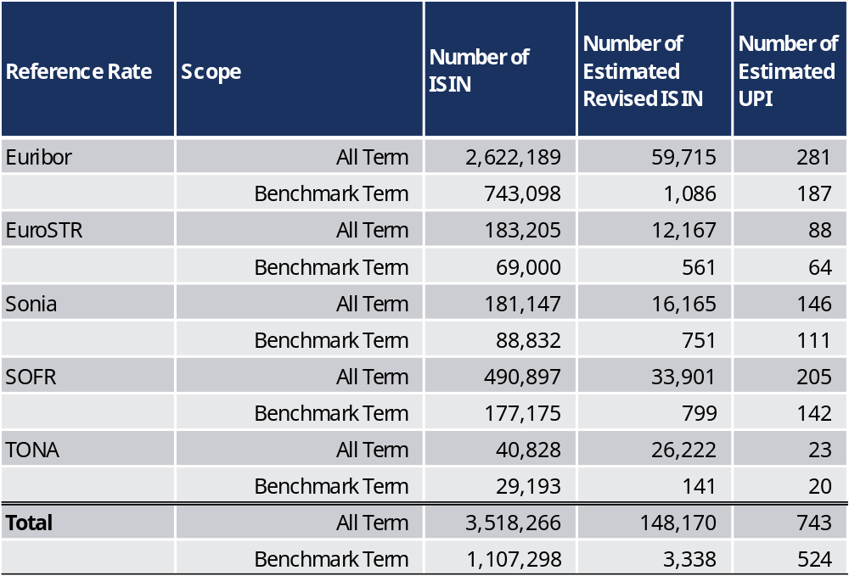

Table 1.3A illustrates that a move to a revised OTC ISIN in accordance with the EC’s DA would significantly reduce the number of OTC ISINs that are currently created for fixed-float IRS.

Specifically, the DSB estimates that the move to the estimated revised OTC ISIN would result in circa 96% reduction of all term, and 99.7% of benchmark term, OTC ISINs created for fixed-float IRS. The removal of the daily redundant OTC ISINs for IRS would reduce the burden for firms whilst still ensuring that meaningful data for this use case was not compromised.

The DSB notes that whilst using the UPI would reduce the number of identifiers for IRS further (by circa 99.95% and 99.98% for all term and benchmark term respectively), this would remove key information – in particular, the contract term – required for transaction reporting and additional data fields would need to be reported with the UPI to provide meaningful transaction data. This approach would also increase the potential for errors through the reporting of multiple data points.

- Comparability of similar ETD and OTC instruments

It may also be beneficial to consider for instruments that are similar in risk and characteristics across both ETD and OTC derivatives, whether the identifiers used should have similar data to make comparison easier.

The DSB has provided examples of similar derivatives traded ETD versus OTC and the respective data that is embedded within a given identifier (or implied within it from the related identifier, CFI).

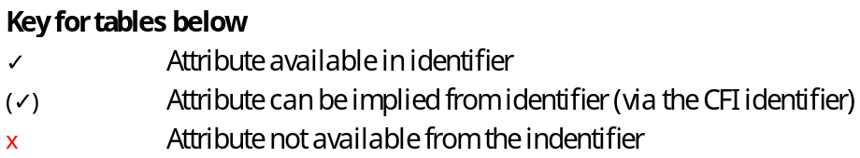

Table 2A: Equity Option on Single Name ETD versus OTC
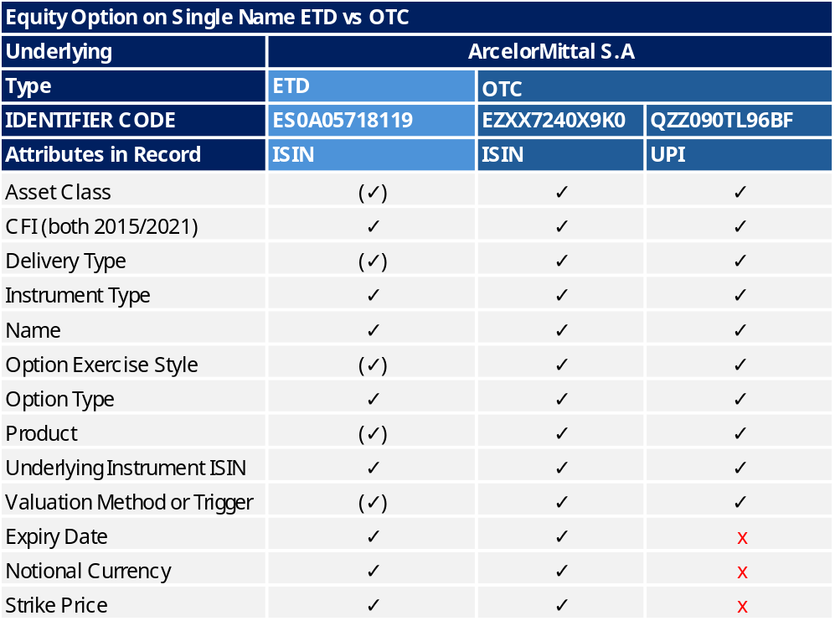

Table 2B: Equity Option on Index ETD versus OTC
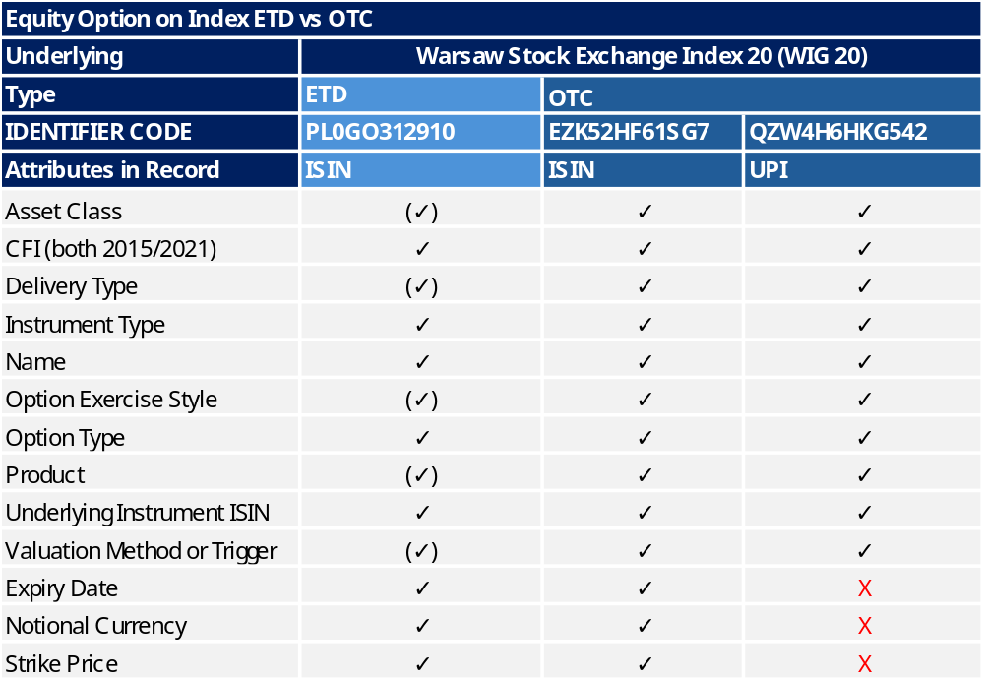

Table 2C: ETD Bond Futures vs OTC Bond Forward
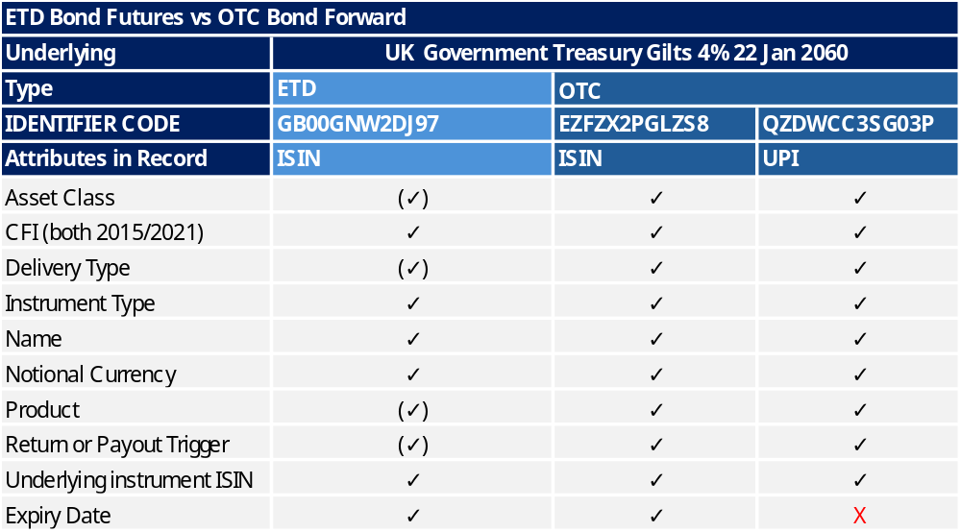

Table 2D: ETD Equity Futures vs OTC Equity Forward
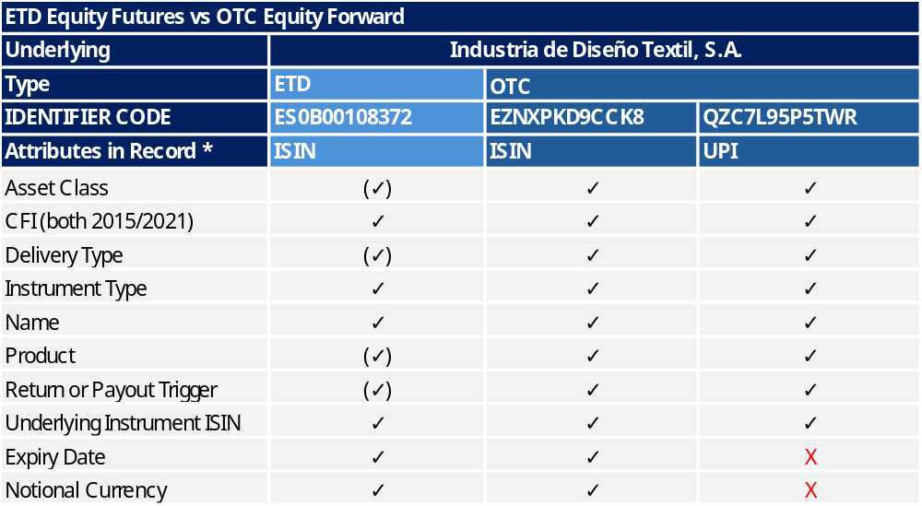

In the examples provided above, the OTC ISIN comprises the same data attributes that are available within the ISIN for a similar ETD instrument.

If the UPI is used as the OTC derivative instrument identifier, additional information would need to be reported separately to ensure that authorities and industry have comparable information with similar ETD instruments and to ensure that their principle of 'Preserve information scope’ is maintained.

CONCLUSION
The DSB has prepared the above analysis with the intent that it assists ESMA in its decision-making as it takes forward the proposals set out in the Call for Evidence. In particular, the DSB has aimed to highlight key points for consideration with respect to addressing the concern on maintaining data quality in a move to single side reporting.

The DSB is ready and willing to provide further analysis should ESMA consider that useful for its deliberations.

<ESMA_QUESTION_CASR_5>

- What are the key advantages of option 1b and how do these benefits address the issues in section 3?
<ESMA_QUESTION_CASR_6>
TYPE YOUR TEXT HERE
<ESMA_QUESTION_CASR_6>

- What are the key limitations and potential risks of option 1b?
<ESMA_QUESTION_CASR_7>
TYPE YOUR TEXT HERE
<ESMA_QUESTION_CASR_7>

- What components are missing or not adequately addressed in option 1b? Why are these elements important, and how might their inclusion change the evaluation or implementation of option 1b?
<ESMA_QUESTION_CASR_8>
TYPE YOUR TEXT HERE
<ESMA_QUESTION_CASR_8>

- What are the key advantages of option 2a and how do these benefits address the issues in section 3?
<ESMA_QUESTION_CASR_9>
TYPE YOUR TEXT HERE
<ESMA_QUESTION_CASR_9>

- What are the key limitations and potential risks of option 2a?
<ESMA_QUESTION_CASR_10>
TYPE YOUR TEXT HERE
<ESMA_QUESTION_CASR_10>

- What components are missing or not adequately addressed in option 2a? Why are these elements important, and how might their inclusion change the evaluation or implementation of option 2a?
<ESMA_QUESTION_CASR_11>
TYPE YOUR TEXT HERE
<ESMA_QUESTION_CASR_11>

- What are the key advantages of option 2b and how do these benefits address the issues in section 3? What regimes should be included in such an option beyond EMIR, MiFIR and SFTR?
<ESMA_QUESTION_CASR_12>
TYPE YOUR TEXT HERE
<ESMA_QUESTION_CASR_12>

- What are the key limitations and potential risks of option 2b?
<ESMA_QUESTION_CASR_13>
TYPE YOUR TEXT HERE
<ESMA_QUESTION_CASR_13>

- What components are missing or not adequately addressed in option 2b? Why are these elements important, and how might their inclusion change the evaluation or implementation of option 2b?
<ESMA_QUESTION_CASR_14>
TYPE YOUR TEXT HERE
<ESMA_QUESTION_CASR_14>

- Which of the two main options (1. “removal of duplication in current frameworks” or 2. "report once") and related sub-options identified do you believe should be prioritised, and why?
<ESMA_QUESTION_CASR_15>
TYPE YOUR TEXT HERE
<ESMA_QUESTION_CASR_15>

- Are there any additional options that should be considered on top of option 1 and 2? For example, do you identify other potential intermediate solutions, combinations of elements from the identified options, or phased approaches? If so, what are their main characteristics, the reasons for considering them, and the key advantages they would bring?
<ESMA_QUESTION_CASR_16>
TYPE YOUR TEXT HERE
<ESMA_QUESTION_CASR_16>

- Should the reporting channels, and flows be modified to ensure consistent reporting, and if so, how? Under which option/s do you consider these changes should be implemented?
<ESMA_QUESTION_CASR_17>
TYPE YOUR TEXT HERE
<ESMA_QUESTION_CASR_17>

- In this regard, and based on the current order book requirements for trading venues and the availability of information, what are the advantages and disadvantages of transferring the reporting of on-venue transactions under MiFIR and EMIR to trading venues?
<ESMA_QUESTION_CASR_18>
TYPE YOUR TEXT HERE
<ESMA_QUESTION_CASR_18>

- Additionally, what are your views on enhancing ESMA role as data hub by developing a framework where entities would report consistent and harmonised data directly to ESMA? Should this option consider direct reporting to ESMA coupled with EU and national authorities’ access to the centrally held data, eliminating multiple submissions?
<ESMA_QUESTION_CASR_19>
TYPE YOUR TEXT HERE
<ESMA_QUESTION_CASR_19>

- In the case of centralisation of reporting, please expand on the advantages and disadvantages as well as the implementation challenges and opportunities? Under this scenario, what additional elements should be considered (i.e. Operational aspects, technical implementation, etc.)
<ESMA_QUESTION_CASR_20>
TYPE YOUR TEXT HERE
<ESMA_QUESTION_CASR_20>

- Do you consider that other technologies (e.g. DLT and Smart Contracts) should be considered as a way to simplify the reporting process?
<ESMA_QUESTION_CASR_21>
TYPE YOUR TEXT HERE
<ESMA_QUESTION_CASR_21>

- Where do you think the cost associated with dual sided reporting is generated? What would be the cost impact of removing dual-sided reporting (e.g. Substituting reconciliation requirements with other measures such as audits against internal record systems as required in the U.S. or increase interaction among counterparties and NCAs)? Do you consider that dual sided reporting may reduce the ability of reporting entities to fully control the data submitted to authorities? Do you consider that the reporting should be strictly from one side?
<ESMA_QUESTION_CASR_22>
TYPE YOUR TEXT HERE
<ESMA_QUESTION_CASR_22>

- Would you consider the modification of reporting frequency useful under the general objective of reducing the reporting burden, and why? What would be the specific proposals in this regard?
<ESMA_QUESTION_CASR_23>
TYPE YOUR TEXT HERE
<ESMA_QUESTION_CASR_23>

- Proportionality measures: how do you consider proportionality can be taken into account in the context of burden reduction in regulatory reporting? What specific measures would you propose and how would you quantify their impact?
<ESMA_QUESTION_CASR_24>
TYPE YOUR TEXT HERE
<ESMA_QUESTION_CASR_24>

- Question for reporting entities under EMIR: what is the one-off cost of implementing EMIR requirements to date? This cost should include all cost lines, such as familiarisation with obligations, staff recruitment, training, legal advice, consultancy fees, project management and investment/updating in it. Do you identify any other relevant one-off cost line?
<ESMA_QUESTION_CASR_25>
TYPE YOUR TEXT HERE
<ESMA_QUESTION_CASR_25>

- Question for reporting entities under EMIR: what is your estimated average cost per transaction (on-going cost) to comply with the reporting requirements under EMIR? This cost should include not only the fees associated with reporting through trade repositories (which usually includes data collection and information storage) but also the total cost, including any other cost lines, such as, IT maintenance and support, training, data processing and audit fees. Do you identify any other relevant ongoing cost line?
<ESMA_QUESTION_CASR_26>
TYPE YOUR TEXT HERE
<ESMA_QUESTION_CASR_26>

- Question for reporting entities under MiFIR: what is the one-off cost of implementing mifir requirements to date? This cost should include all cost lines, such as familiarisation with obligations, staff recruitment, training, legal advice, consultancy fees, project management and investment/updating in it. Do you identify any other relevant one-off cost line?
<ESMA_QUESTION_CASR_27>
TYPE YOUR TEXT HERE
<ESMA_QUESTION_CASR_27>

- Question for reporting entities under MiFIR: what is your estimated average cost per transaction (on-going cost) to comply with the reporting requirements under MiFIR? This cost should include not only the fees associated with reporting through Approved Reported Mechanisms but also the total cost, including any other cost lines, such as, IT maintenance and support, training, data processing and audit fees. Do you identify any other relevant ongoing cost line?
<ESMA_QUESTION_CASR_28>
TYPE YOUR TEXT HERE
<ESMA_QUESTION_CASR_28>

- Question for reporting entities under EMIR or MiFIR: Are there other cost-factors that we should consider when estimating the cost saving over a long term horizon?
<ESMA_QUESTION_CASR_29>
TYPE YOUR TEXT HERE
<ESMA_QUESTION_CASR_29>

- What are the anticipated investments and transition costs associated with implementing option 1a, 1b, 2a and 2b (e.g. Decommissioning of legacy systems, adapting systems to new changes and future evolving requirements, etc.)? Please provide a detailed breakdown of these costs, including any one-off and ongoing expenses. What is the estimated average cost saving per transaction?
<ESMA_QUESTION_CASR_30>
TYPE YOUR TEXT HERE
<ESMA_QUESTION_CASR_30>

Harmonisation of the Unique Product Identifier - Technical Guidance

